**Can effective residual waterhemp control AND successful establishment of interseeded or overseeded cover crops into corn be achieved?**

Waterhemp has become the most troublesome weed species across Wisconsin cropping systems and has developed resistance to different POST herbicides (please see: <https://storymaps.arcgis.com/stories/9ae6d1c164e24c7987432dbe1cf67d0e>). PRE-emergence (PRE) herbicides with soil residual activity have become the foundation for chemical waterhemp control. However, the use of such herbicides can also negatively impact the establishment of cover crops interseeded or overseeded into corn (Figure 1A & B). A potential strategy for achieving effective waterhemp control and cover crop establishment is to use effective PRE herbicides and compatible cover crop species which is the main goal of the research described herein.

If you are not familiar with interseeding and overseeding, these are two methods of establishing cover crops into a standing crop, such as corn. Interseeding involves planting the cover crop between the rows of the main crop early in the growing season, while the main crop is still growing; V3-V7 as the recommended growth stages for cover crop interseeding in corn (Figure 1A). On the other hand, overseeding involves establishing the cover crop just before or at crop maturity (Figure 1B). Thus, interseeding and overseeding allow for earlier planting before corn harvest, which buys time for cover crop establishment and biomass production compared to the cover crop planted after harvest, particularly important in regions with short growing season such as Wisconsin.

|  |
| --- |
| A tractor in a field  Description automatically generated with medium confidence  B  A |

**Figure 1.** Interseeding (A) [Smith et al. 2021] and overseeding (B) cover crop into corn (Staudt, 2015).

<https://learningstore.extension.wisc.edu/collections/farming/products/interseeding-cover-crops-in-row-cultivated-corn>

<https://iowalearningfarms.wordpress.com/2015/09/09/cover-crop-seeding-techniques-interseeding/>

More growers across the US Midwest are considering interseeding and overseeding cover crops into corn to reduce soil erosion, improve soil health, suppress weeds, increase biodiversity, and provide forage or grazing opportunities for livestock. Remember, if your crop is harvested for human consumption or animal feed, *you must comply with the plant-back intervals (PBIs)* established by the U.S. Environmental Protection Agency (EPA) that dictate **the minimum period of time between a pesticide application and the planting of your next crop**. PBI restrictions do not apply to cover crops planted solely to improve soil quality, reduce erosion or manage weeds (which is the focus of this research effort), since there is no risk of animal and human dietary exposure.

Now let’s bring back the residual PRE herbicides and interseeding and overseeding concept. Based on the challenges in controlling troublesome weeds, such as waterhemp, and the potential risk of weed resistance, the WiscWeeds Program recommends **PRE herbicide premixes with at least two sites of action (SOA) “***Waterhemp Research Summary: What we have learned from 5 years of chemical waterhemp control in soybean”*[**https://wiscweeds.info/images/2023ResearchReport/WaterhempMultiTrialSummary2019_2022.pdf**](https://wiscweeds.info/images/2023ResearchReport/WaterhempMultiTrialSummary2019_2022.pdf)for enhancing residual weed control, which limits the cover crop species options to be interseeded or overseeded into corn. This begs the question: ‘Is the interseeding or overseeding system a reality for Wisconsin corn growers that have waterhemp in their fields?’ We established two studies in 2021 and 2022 to start answering this question. One was conducted in the field to select PRE herbicides that provided effective waterhemp control and another in the greenhouse using field-treated soil via bioassay to select potential herbicides that caused minimal impact on cover crops established at different times after application.

**Field study:** treatments consisted of 18 single and multiple sites of action (SOAs) PRE herbicides plus a nontreated check.

**Greenhouse bioassay (Figure 2):** four bioindicator cover crop species were used in the greenhouse bioassay: annual ryegrass (*Lolium multiflorum* L.), cereal rye (*Secale cereale* L.), radish, (*Raphanus sativus* L.), and red clover (*Trifolium pratense* L.). We used field-treated soil at 30 DAT (V3 corn growth stage - interseeding system) and 70 DAT (V10 corn growth stage - overseeding system) after treatment (see video <https://www.youtube.com/watch?v=0cloiyRrRoU&t=3s> ). The data (cover crop injury and biomass) were collected 28 days after sowing the cover crop seeds.

|  |
| --- |
| A picture containing plant  Description automatically generatedA picture containing greenhouse, plant, flower, garden  Description automatically generated  B  A |

**Figure 2.** Cover crop species (A): Radish (top right corn), cereal rye (top left corner), red clover (bottom right corner), and annual ryegrass (bottom left corner); cover crops growing at the greenhouse (B); *Pictures taken by Tatiane Severo Silva on 09/24/2022.*

**Field results:** most herbicides provided >75% of waterhemp control (Figure 3) and as expected, herbicide premixes with more than one SOA tended to provide better waterhemp control than herbicides with a single SOA (See the last released report by WiscWeeds “[**2022 Wisconsin Weed Science Research Report (PDF)**](https://wiscweeds.info/images/2022%20Research%20Report/2022%20Wisconsin%20Weed%20science%20Research%20Report.pdf)” for more detailed results and information).

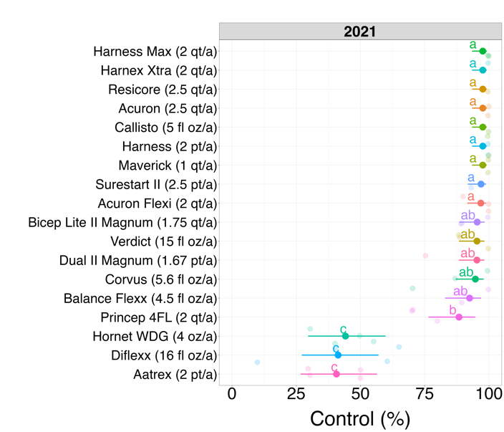

**Figure 3.** Waterhemp (*Amaranthus tuberculatus* L.) control by soil residual herbicides applied PRE in 2021 (left) and 2022 (right).

***How about the cover crops? Did these herbicides negatively impact the establishment of cover crops?***

**Greenhouse bioassay results (Figures 4):** In fact, premixes with 2 & 3 SOAs had a higher negative impact on cover crops than herbicides with a single SOA.

* All SOA groups (2 [thiencarbazone-methyl], 4 [clopyralid], 14 [saflufenacil], 15 [acetochlor and S-metolachlor], 27 [mesotrione and dimethenamid-P]) PRE herbicides tested, except 5 (atrazine and simazine), resulted in biomass reduction of at least one cover crop at 30 and 70 days after treatment (DAT).
* Annual rye and cereal rye were sensitive to treatments containing herbicide group 15 (acetochlor and S-metolachlor) but not as impacted by herbicide groups 2, 4, 5, 14, and 27 at 30 and 70 DAT.
* Radish and red clover were sensitive to herbicide groups 2, 4, and 27 whereas groups 5, 14, and 15 had minimal impact on their establishment.

|  |
| --- |
| A picture containing plant, flower, vegetable  Description automatically generated  D  A  Bb  C |

**Figure 4.** Injury of S-metolachlor on cereal rye (A) and annual ryegrass (B) and mesotrione injury on radish (C) and red clover (D). *Pictures taken by Tatiane Severo Silva on 09/17/2022.*

In summary, PRE herbicide premixes had a better overall performance in waterhemp control compared to PRE with a single SOA, but had greater negative impact on cover crop establishment. Cereal rye was the least sensitive species to the most effective herbicides for waterhemp control, followed by radish. Red clover and annual rye were the most sensitive cover crop species to the most effective herbicides for waterhemp control.

**Take Home:**

* There is a potential to achieve effective residual waterhemp control while also interseeding or overseeding cover crops into corn. However, it requires careful planning and management. For instance, cover crops species interseeded or overseeded into corn should be carefully selected depending on the residual PRE herbicide applied.
* Cereal rye was the least sensitive species to the most effective herbicides for waterhemp control, followed by radish. Red clover and annual rye were the most sensitive species to the most effective herbicides for waterhemp control.
* This research results focus on cover crops grown for conservation purposes, not for feed. Therefore, farmers should consult both the research data and plant-back intervals (PBIs) when considering crops for animal consumption.

Moving forward, we intend to conduct field experiments to further validate our findings and improve our herbicide selection recommendations. There is still a lot to be learned and research to be conducted in this new system. So, our goal with this article, is to share that it can be challenging, but we also have options for farmers and practitioners interested in this new cover crop-corn management system. Stay tuned for additional information regarding this topic!

The research reported herein was led by Tatiane Severo Silva (PhD). Click here (ADD LINK) to see Silva’s slides presented during the 2022 North Central Weed Science Society Meetings (December 2022) in St. Louis, MO. Silva also presented a video (**Concerned about herbicide carryover with interseeded cover crops? Try a bioassay!)**

at the same Conference, available at <https://www.youtube.com/watch?v=0cloiyRrRoU&t=3s>. Silva won first place with these paper and video presentations (congrats Tati!).

**Additional resources**

**Interseeding Cover Crops (<https://ipcm.wisc.edu/blog/2022/06/interseeding-cover-crops/>)**

**Herbicide Rotational Restrictions FOR COVER AND FORAGE CROPPING SYSTEMS**

**(**[**https://ipcm.wisc.edu/wp-content/uploads/sites/54/2022/11/2019_RotationalRestrictions_final.pdf**](https://ipcm.wisc.edu/wp-content/uploads/sites/54/2022/11/2019_RotationalRestrictions_final.pdf)**)**

**Interseeding Cover Crops into Corn and Soybean: What We’ve Learned (**[**https://cropwatch.unl.edu/2021/interseeding-cover-crops-corn-and-soybean**](https://cropwatch.unl.edu/2021/interseeding-cover-crops-corn-and-soybean)**)**

This article was written by Tatiane Severo Silva (PhD), Nick Arneson (Outreach Program Manager), and Rodrigo Werle (Assistant Professor). All authors are affiliated with UW-Madison.

Thanks to Ryan DeWerff (Research Specialist) and Dan Smith (Outreach Specialist) for their assistance with these experiments, and the WiscWeeds team, Rock County Farm, and Lancaster Agricultural Research staff for supporting this research.